WEB PHISHING DETECTI0N

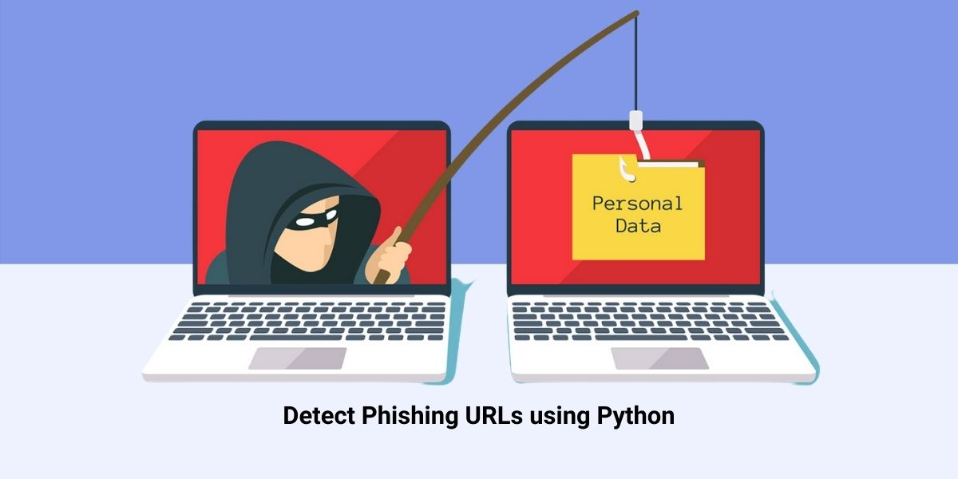

**PROBLEM-SOLUTION -FIT**

***TEAM DETAILS***

*TEAM NUMBER : PNT2022TMID34399*

*COLLEGE NAME : CAPE INSTITUTE OF TECHNOLOGY*

*DEPARTMENT : INFORMATION TECHNOLOGY*

**PROBLEM MEMBERS**

* ISWARYA.A
* PARVATHY.T
* SALINI.T
* SAHAYA ABISHA.A



PROBLEM SOLUTION FIT



